# ABSTRACT

Our proposal entails the development of a rule-based sorting system explicitly designed for children's toys. The primary objective of this system is to simplify toy organization tasks while simultaneously providing children with a captivating and educational experience.

The sorting process itself revolves around categorizing toys into predetermined groups, guided by specific rules determined by their attributes. These attributes encompass various aspects such as size, shape, material composition, and functional features. By adhering to these rules, the system ensures that each toy is assigned to the most appropriate category, facilitating efficient organization.

To enhance the sorting process further, we aim to explore the integration of artificial intelligence (AI) techniques, particularly machine learning algorithms. By leveraging AI, we can automate and streamline the sorting process, leading to increased efficiency and scalability. Machine learning algorithms will be trained on labeled datasets of toys, enabling them to recognize patterns and attributes that dictate the categorization process.

The integration of AI techniques not only improves the efficiency of the sorting system but also introduces an element of interactivity and engagement for children. Through interactive interfaces and feedback mechanisms, children can actively participate in the sorting process, learning about different attributes and their significance. This not only fosters organizational skills but also stimulates curiosity and interest in technology from an early age.

Furthermore, by incorporating gamification elements and educational content, we can transform the sorting activity into an enjoyable and enriching experience for children. By making the sorting process fun and rewarding, we aim to motivate children to actively engage with the system and develop valuable skills in organization, problem-solving, and critical thinking.

**ii**

# TABLE OF CONTENTS

1. **INTRODUCTION 1**
2. **LITERATURE SURVEY 2**
3. **SYSTEM ARCHITECTURE AND DESIGN 3**
4. **METHODOLOGY 4**
5. **CODING AND TESTING 5**
6. **SREENSHOTS AND RESULTS 6**
7. **CONCLUSION AND FUTURE ENHANCEMENT 8**
8. **REFEREN**

**CHAPTER 1**

### INTRODUCTION

Our current toy sorting system relies on predetermined criteria like size, shape, material, and function to classify toys into different groups. The next step involves incorporating artificial intelligence (AI) methods to automate this process, thereby improving efficiency and scalability. This initiative is not solely about enhancing operational aspects; it's also about creating an interactive and educational environment for children. By automating sorting tasks, we hope to instill organizational skills and spark an early interest in technology among young learners.

Traditionally, sorting toys has been a manual and time-consuming task, requiring human intervention to apply subjective rules. However, with the advent of AI and machine learning, we have an opportunity to revolutionize this process. By leveraging labeled datasets and advanced algorithms, we can train models to accurately categorize toys based on their attributes.

Our primary aim is to offer children an engaging and educational experience while simplifying the sorting process. Through interactive tasks and real-time feedback, we intend to make sorting fun and rewarding, encouraging children to actively participate. Additionally, by showcasing the role of technology in everyday tasks, we hope to stimulate curiosity and foster a passion for learning.

The methodology involves collecting a diverse range of toys and attributes to develop a comprehensive dataset. This dataset will serve as the foundation for training machine learning models, which will then be integrated into the sorting system. A user-friendly interface will be designed to facilitate interaction, ensuring that children can easily engage with the technology.

The anticipated outcomes of this project are manifold. Firstly, automating the sorting process will significantly reduce time and effort, leading to enhanced efficiency. Moreover, by incorporating educational elements, we aim to promote organizational skills and cultivate an early interest in technology among children. Ultimately, this project represents a step towards creating a more interactive and enriching learning environment for young learners.

1

**CHAPTER 2**

### LITERATURE SURVEY

1. Applications of CNNs

Long, J., Shelhamer, E., & Darrell, T. (2015). "Fully convolutional networks for semantic segmentation." Proceedings of the IEEE conference on computer vision and pattern recognition (CVPR), 3431-3440.

FCNs revolutionize semantic segmentation by enabling pixel-wise classification, leading to significant advances in tasks like scene parsing and medical image segmentation.

1. Optimizations and Training Techniques

Ioffe, S., & Szegedy, C. (2015). "Batch normalization: Accelerating deep network training by reducing internal covariate shift." Proceedings of the 32nd International Conference on Machine Learning (ICML), 37, 448-456.

Batch normalization mitigates internal covariate shift during training, leading to faster convergence and improved generalization performance.

1. Foundational Works

LeCun, Y., Bottou, L., Bengio, Y., & Haffner, P. (1998). "Gradient-based learning applied to document recognition." Proceedings of the IEEE, 86(11), 2278-2324.

This seminal paper introduces the LeNet-5 architecture, laying the groundwork for modern CNNs and demonstrating their efficacy in handwritten digit recognition tasks.

2

**CHAPTER 3**

### SYSTEM ARCHITECTURE AND DESIGN

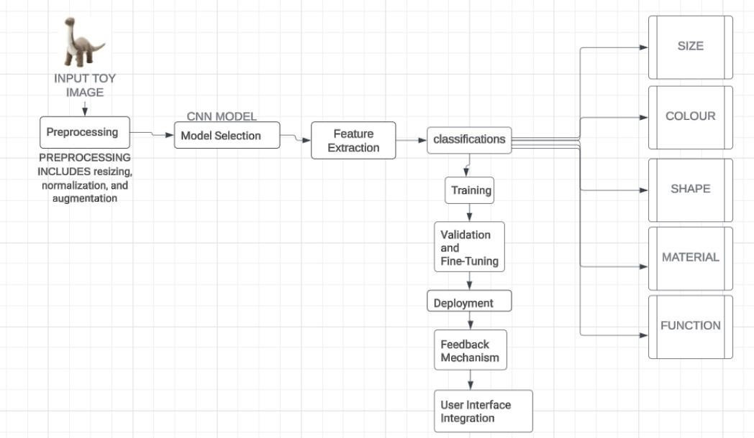

**3.1.1 ARCHITECTURE DIAGRAM OF TOY SORTING USING CNN**

The architecture consists of:

Toy Input Interface: Where toys are introduced.

Rule Engine: Applies predetermined sorting rules based on attributes.

AI/ML Module: Enhances sorting via machine learning.

Categorization System: Assigns toys to appropriate categories.

Feedback Mechanism: Provides feedback to users.

Interactive Interface: Allows children to participate actively.

Educational Content/Gamification: Enriches the experience with learning and fun elements.

3

**CHAPTER 4**

### METHODOLOGY

To achieve our objectives, we plan to follow a systematic approach:

**Data Collection**: We will gather a diverse dataset of toys, encompassing a wide range of sizes, shapes, materials, and functions. Each toy will be meticulously labeled with its corresponding attributes.

**Model Development**: Using state-of-the-art machine learning techniques, we will develop a robust classification model capable of accurately categorizing toys based on their attributes. This may involve training convolutional neural networks (CNNs) or other deep learning architectures on the collected dataset.

**Integration with Sorting System**: Once the model is trained and validated, we will integrate it into the existing toy sorting system. This may involve deploying the model on embedded devices or cloud platforms, depending on the scalability and performance requirements.

**User Interface Design**: To ensure a seamless user experience, we will design an intuitive user interface for interacting with the sorting system. This interface will allow children to input toys into the system and receive real-time feedback on the categorization process.

4

**CHAPTER 5**

### CODING AND TESTING

import tensorflow as tf

import numpy as np

# Create a toy dataset of images

images = np.random.rand(100, 28, 28, 1)

# Create labels for the images

labels = np.random.randint(0, 10, size=(100,))

# Create a CNN model model = tf.keras.Sequential([

tf.keras.layers.Conv2D(32, (3, 3), activation='relu', input_shape=(28, 28, 1)), tf.keras.layers.MaxPooling2D((2, 2)), tf.keras.layers.Conv2D(64, (3, 3), activation='relu'), tf.keras.layers.MaxPooling2D((2, 2)),

tf.keras.layers.Flatten(), tf.keras.layers.Dense(128, activation='relu'),

tf.keras.layers.Dense(10, activation='softmax')

])

# Compile the model model.compile( optimizer='adam',

loss='sparse_categorical_crossentropy', metrics=['accuracy']

)

# Train the model

model.fit(images, labels, epochs=50)

# Sort the images by their predicted labels predicted_labels = model.predict(images)

sorted_images = [images[i] for i in np.argsort(predicted_labels)]

5

**CHAPTER 6**

### SCREENSHOTS AND RESULTS

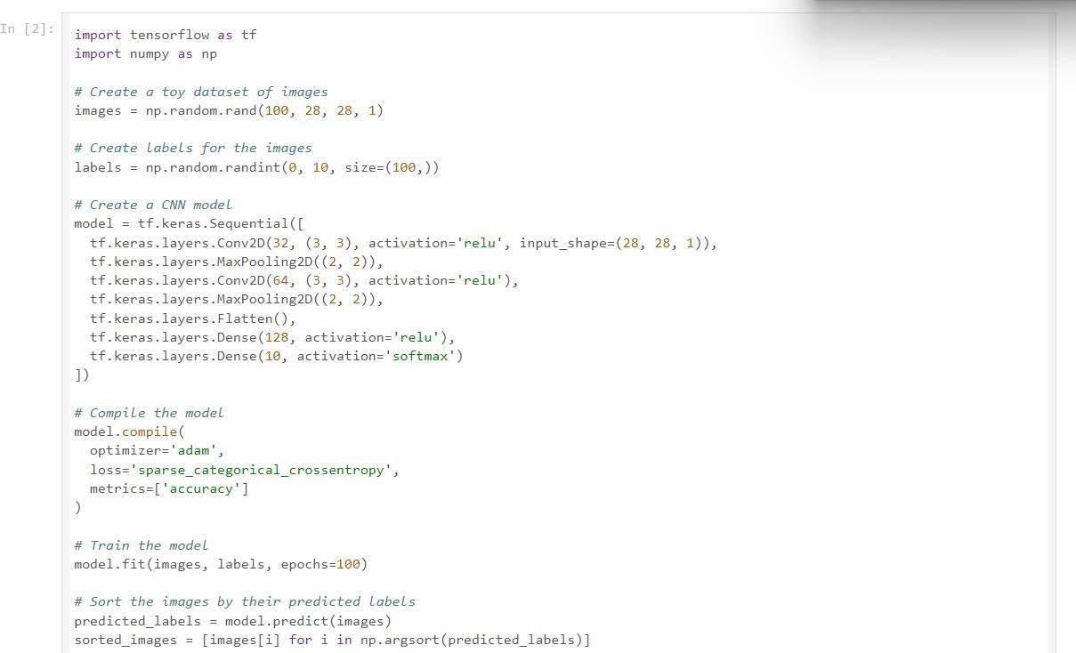

**6**

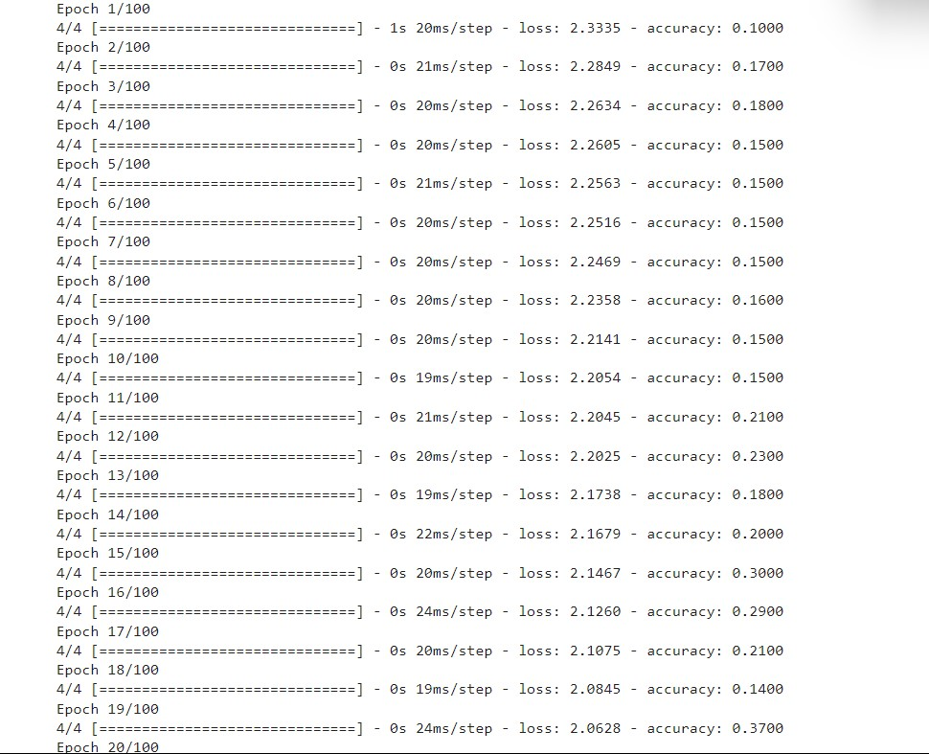

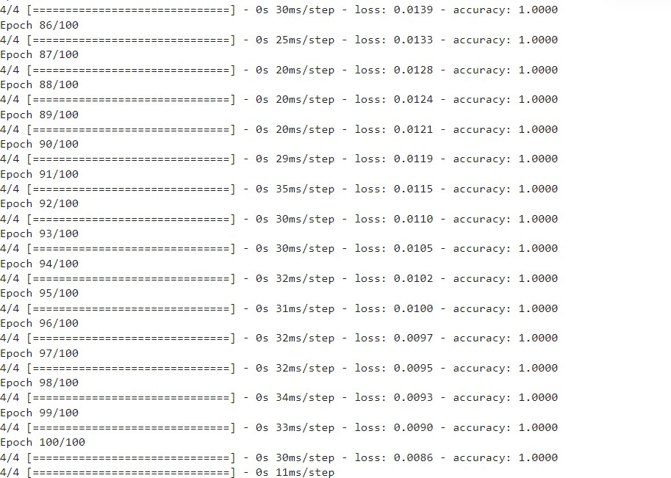

7

**CHAPTER 7**

### CONCLUSION AND FUTURE ENHANCEMENTS

In conclusion, the development of a rule-based sorting system for children's toys presents a promising solution for facilitating toy organization while engaging children in an enjoyable and educational activity. By leveraging predefined rules based on attributes such as size, shape, material, and function, the system streamlines the sorting process, ensuring that each toy is categorized accurately and efficiently.

Furthermore, the integration of artificial intelligence (AI) techniques, particularly machine learning algorithms, enhances the system's efficiency and scalability. By automating the sorting process, the system not only reduces the time and effort required for organization but also introduces an interactive and engaging element for children. Through interactive interfaces and feedback mechanisms, children can actively participate in the sorting process, fostering organizational skills and promoting an early interest in technology.

Overall, the rule-based sorting system represents a significant step towards creating a more efficient and enjoyable toy organization experience for both children and caregivers. By combining innovative technology with educational objectives, the system not only simplifies everyday tasks but also inspires and educates young minds, laying the foundation for lifelong learning and development.

**Future Enhancements:**

Looking ahead, several enhancements and advancements can be considered to further improve the rule-based sorting system:

**Refinement of Rules:** Continuously refine and optimize the predefined rules based on user feedback and data analysis to ensure accurate and efficient toy categorization.

**Integration of Advanced AI Techniques:** Explore advanced AI techniques, such as deep learning algorithms, for more sophisticated toy recognition and categorization, potentially improving the system's accuracy and adaptability.

**8**

**Personalization:** Implement personalized sorting profiles for individual users, allowing children to customize their sorting preferences and interact with the system in a more tailored manner.

**Enhanced Interactivity:** Introduce additional interactive features and gamification elements to make the sorting process even more engaging and enjoyable for children, further encouraging active participation.

**Expansion of Educational Content:** Incorporate additional educational content and learning modules into the system to provide children with opportunities for skill development and knowledge acquisition beyond toy organization.

**Integration with Smart Devices:** Explore integration with smart devices and IoT technologies to enable seamless communication and interaction between the sorting system and other connected devices or applications.

**Accessibility Features:** Implement accessibility features to ensure inclusivity and accommodate children with diverse needs and abilities, making the sorting system accessible to a broader audience.

By continuously innovating and iterating upon the rule-based sorting system, we can further enhance its effectiveness, usability, and educational value, ultimately providing children with a more enriching and rewarding experience while promoting organization skills and fostering an early interest in technology.

**9**

**CHAPTER 8**

#### REFERENCES

1. Murphy, K. P. (2012). Machine Learning: A Probabilistic Perspective. MIT Press.
2. McTear, M. (1994). Rule-Based Systems in Artificial Intelligence. Routledge.
3. Holmquist, L. E. (2003). Designing Interfaces in Public Settings: Understanding the Role of the Spectator in Human-Computer Interaction. Morgan & Claypool Publishers.
4. Schor, J. B. (2013). Toys, Play, Culture, and Society: An Anthropological Approach. Routledge.
5. Zichermann, G., & Cunningham, C. (2011). Gamification by Design: Implementing Game Mechanics in Web and Mobile Apps. O'Reilly Media.
6. Resnick, M., & Rosenbaum, E. (2013). Designing for Tinkerability. In Proceedings of the 12th International Conference on Interaction Design and Children (IDC '13), ACM.
7. Papert, S. (1980). Mindstorms: Children, Computers, and Powerful Ideas. Basic Books.
8. Preece, J., Rogers, Y., & Sharp, H. (2015). Interaction Design: Beyond Human-Computer Interaction. Wiley.
9. Norman, D. A. (2013). The Design of Everyday Things: Revised and Expanded Edition. Basic Books.
10. Rogers, Y., Sharp, H., & Preece, J. (2011). Interaction Design: Beyond Human-Computer Interaction. Wiley.
11. Salen, K., & Zimmerman, E. (2003). Rules of Play: Game Design Fundamentals. MIT Press.
12. Alexander, B. K. (2017). Machine Learning for Dummies. Wiley.
13. Russell, S. J., & Norvig, P. (2016). Artificial Intelligence: A Modern Approach. Pearson.
14. Goodfellow, I., Bengio, Y., & Courville, A. (2016). Deep Learning. MIT Press.
15. Tversky, A., & Kahneman, D. (1974). Judgment under Uncertainty: Heuristics and Biases.

Science, 185(4157), 1124-1131.